2022 PSCFA Cool Off - Coaches Meeting Agenda
April 30, 2020 - 1:00 pm
Virtual -
https://laccd.zoom.us/j/97726270091?pwd=V1RoWUNpZW91VVR5L0xOb0dyZDFpQT09
Meeting ID: 977 2627 0091
Passcode: 117693

Schools in Attendance: Rio, Moorpark, Mesa, Cerritos, Fullerton, IVC, Palomar, Mt. Sac, Concordia, MSJC, SMC, Grossmont, El Camino, SDSU

Proxy Votes: None

- Approval of 2021 Coaches Conference Meeting Minutes – Approved
- Coaches Conference Bids – September 9-11, 2022
  - Current Bid
    - Appendix A: Omni Rancho Las Palmas Resort – Das
    - Avg 40 rooms a night Friday and Sat
    - Offering us room rates from 2020.
  - New Bids
    - Appendix B: Big Bear Lake at the Holiday Inn Resort - Ralph
    - We will look into BB for next year and get more information because everyone is interested. Thanks Ralph!
- PSCFA Executive Board
  - Vice President Elections – 2-year term
    - Alix Lopez – VP 2022-2024
    - Other nominations – Damon Mitchel
- Tournament Calendar
  - Appendix C: Current Tournaments/Dates
    - Updates - you can update it here. Please, note if the tournament is to be held virtual (synchronous / asynchronous) or if it is still an undetermined modality.
    - Please submit any changes or updates after summer prior to the Coaches Conference to pscfaexecsec@gmail.com
- PSCFA- 2022-2023 -Tournament Hosts
  - Seminar, September 18th –
  - Warm-Up, October 1st -2nd - ELCO
  - Fall Champs, December 2nd – 4th – Cerritos
  - Spring Champs, February 24th -25th - Palomar
  - Cool-Off, April 29th – 30th - RIO
- Treasurer's Report
  - Appendix D
- New Hires
  - Holland Smith – Full-Time, Assistant Director at Palomar!!!!
  - Hailey Stone – SDSU, Coach
  - Will White – SDSU, Coach
- Announcements
  - Panels/Ideas for Coaches Conference - Master Classes.
    - Please, fill out the google form with suggestions.
  - Bovaro Winners – Here is a link of the list. If you know any of the missing winners, please, email Nichole at pscfaexecsec@gmail.com with the following information: competitor’s name, school year, and place.
  - May 6th – Join the FACCCC Regional Meeting, San Diego Mesa College 7250 Mesa College Dr., SD 92111, May 6th 11-1, SB117, valid faculty parking passes in SD county work or park in student parking.
  - Monday, AB 928 was spoken about at ICCS – Oral Comm will remain in the GE pattern, Golden Four, there will be a vetting process. WE need to be a part of that vetting process. Course descriptions are written for students not for the professor. UC think there is not enough rigger, so we need to get engaged. Write in etc. CHECK YOUR EMAIL OVER THE SUMMER!
  - Next year, PSCFA President, Secretary, and training for Treasure positions open!
  - Maricopa is hosting PKD in 2024!
Appendix A
Coaches Conference Bid
Omni Rancho Las Palmas
Appendix B
Coaches Conference Bid
Big Bear Lake at the Holiday Inn Resort
8/26-8/30
Cynthia Perez: Cynthia@thelodgeholidayinnresort.com
Room prices in attachments
Number of rooms for lowest cost in attachments
Cost for 3 days in attachments
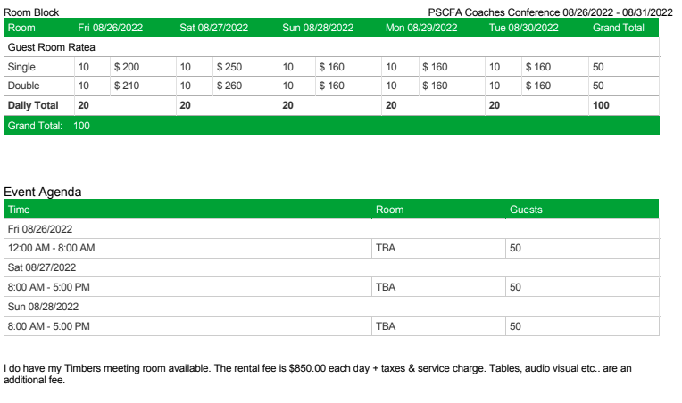

Appendix C
PSCFA Tournament Calendar
2022-2021
*When updating please, note if it is virtual (synchronous or asynchronous) or undetermined modality
Last Updated –
Most recent update on PSCFA.org
Coaches Conference, September 9-11, 2022, TBA - Omni Rancho Las Palmas in Rancho Mirage
PSCFA Seminar, September 18, 2022, OCC – Virtual?
Golden Gate Swing SFSU/CCSF “Warm-Up” Style, September , 2022, San Francisco State University — Virtual, Synchronous
National Online Forensics Quarterly Tournament #1, September , 2022, Virtual, Synchronous
2021 Norene Hokett Invitational, October , 2022 – Live and in-person at California Baptist University. Debate and IEs running against each other.
Warm-Up, October, 1 -2, 2022- ELCO?
Mills Invitational, October , 2022, Palomar College – Canceled
Crossman Invitational, October 14-16, 2022, El Camino College –
Sunset Cliffs, October 21-23, 2022, Pt Loma – Debate and IEs
October Surprise, October , 2022, Mt. Sac
Watson-Lancer, October 21-23, 2022, Pasadena City College – Canceled
Norene Hokett Invitational, October 28-30, 2022 California Baptist University – Free, Virtual and Asynchronous
Robert Barbera Invitational, November 4-6, 2022, CSUN – Synchronous
Blumer Invitational, November-December 2022, CSUF – Virtual, Asynchronous – Novice IEs
Norton, November , 2022 Bradley University
Fall at the Beach, November , 2022, CSULB – Moved to winter
Gary Rybold FREE NPDA, November , 2022, Irvine Valley College – Canceled
Ray Dahlin Invitational, November , 2022, Grossmont College – Canceled
30th Annual Griffin Invitational, November , 2022, Grossmont College – Virtual – Synchronous
The DVC Thing, November 18-20, 2021, DIablo Valley College – Virtual
Friday – IPDA Saturday – PARLI Sunday – LD
Claremont Debate Tournament, November , 2022, Claremont Mekenna College
California Cup, November , 2022, USC, UCLA, Claremont
Fall Championships, December 2-4, 2022,
Fall District I Qualifier, December 10, 2022 –
National Online Forensics Quarterly Tournament #2, December 17, virtual, synchronous
Hell Froze Over Swing, January , 2023, Bradley University
Close to the Coast, January, 2023, Orange Coast College – Canceled
Jannese Davidson, January 28-29, 2023, Concordia University - FREE
PCC Winter Invitational, , 2023, PCC – Canceled
Virginia is for Lovers, February , 2023 James Madison University
Gaske Memorial, February , 2023, SDSU –
CSULA 3rd Hollywood Swing, February (Part 1: Asynch) & (Part 2: Online, Synch), 2023
National Online Forensics Quarterly Tournament #3, February, Virtual, Synchronous
Tabor-Venitsky, February 17-19, 2023, Cerritos – Modality TBA
Western States Conference, February , 2023,
Spring Championships, February 24-26 2023,
Spring District I Swing (Last Chance & Qualifier), March 4 & 5, 2023, – Host/Modality TBA
Claremont College BP, March , Claremont College
Christian Nationals, March 2023, Liberty University
CCCFA State Championships, March , 2023,
International (IFA), March
National Online Forensics College Championship, March 17-19, Virtual, Synchronous
National Speech Championship, March , 2023, George Mason University, Fairfax, Virginia
Pi Kappa Delta (Off-year NCT), March , 2023,
NEDA Nationals, TBA,
Novice Nationals, TBA,
National Parli Tournament (NPDA), March , 2023, Virtual
National Parli Debate Tournament (NPTE), March , 2023 , Virtual
AFA-NIET, April , 2023,
Phi Rho Pi, April 9-15, 2022, Bethesda, MD
The Hornet Invitational, April , 2023, Fullerton College
National Online Forensics Quarterly Tournament #4, April 15, Virtual, Synchronous
Blumer Invitational, , 2023, CSUF – Virtual, Asynchronous – Novice
BP Nationals, April , 2023,
National Online Forensics Festival, End of April , 2023 – Virtual – Synchronous
International Parli, TBA,
NFA, April , 2023, ,
Cool-Off, April 29-30, 2023,

Appendix D
Treasures Report

